

Defect Detection in Images – Cracks Classification
The goal of this project is to develop a deep-learning approach to detect defects—specifically cracks—in images.

I was provided with a dataset of images, some containing visible cracks and some not. The dataset was divided into:
Training Set – Used to train model and test auto-labeling algo.
Validation/Test Set – Used to evaluate.

Naive Data Annotation Approach
To substitute the annotation process, I implemented a naive algorithm that automatically marks potential crack areas using image processing.
- Converted to grayscale
- Applied bilateralFilter
- Used Canny edge detection
- Applied naive thresholding to detect cracks
The algorithm successfully detected crack-like structures in ~96% of images. However, some false positives occurred due to:
- Background textures
- Shadows
- Low contrast edges

Processing examples:
Original Image | Naive Annotated Output
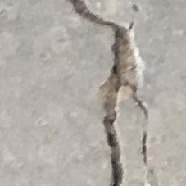 | 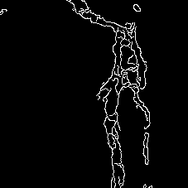
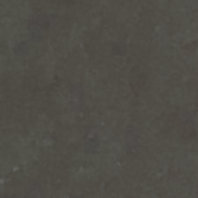 | 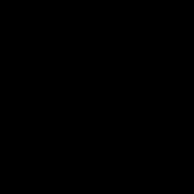
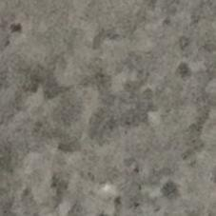 | 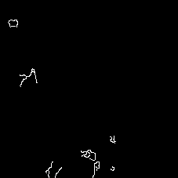
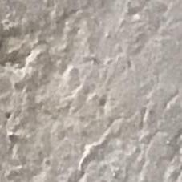 | 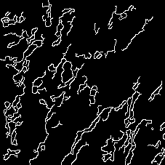

The auto-annotation turned out quite accurate.

Balanced dataset metrics

F1: 0.9612

Confusion matrix: 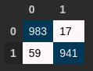

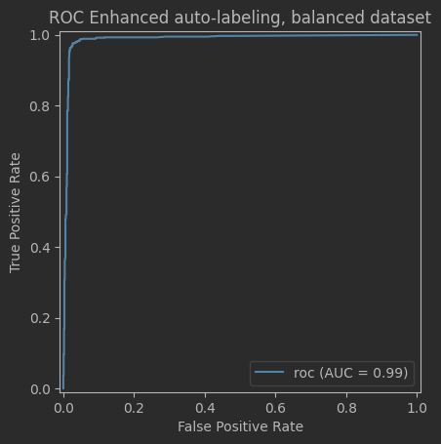

Unbalanced

F1 average: 0.7733
F1 weighted: 0.9846

Confusion matrix: 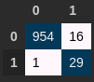

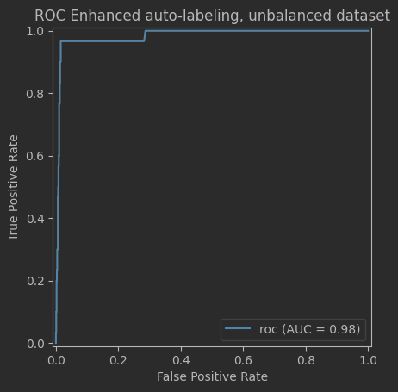

Using the annotated data, I trained an AlexNet-based (just because rgis data shouldn’t require more complex model and I had no time to experiment with architectures) convolutional neural network to classify images.
Model: AlexNet (modified final layer for binary classification)
Input Size: (227×227 resized -> 224×224)
Optimizer: Adam
Loss Function: Cross-Entropy
Learning Rate: 0.001
Epochs: 27
Framework: PyTorch

Balanced

Metric | Value
Accuracy | 0.89
F1 Score | 0.8959

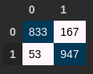

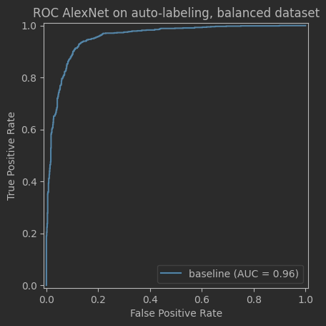

False negative examples:
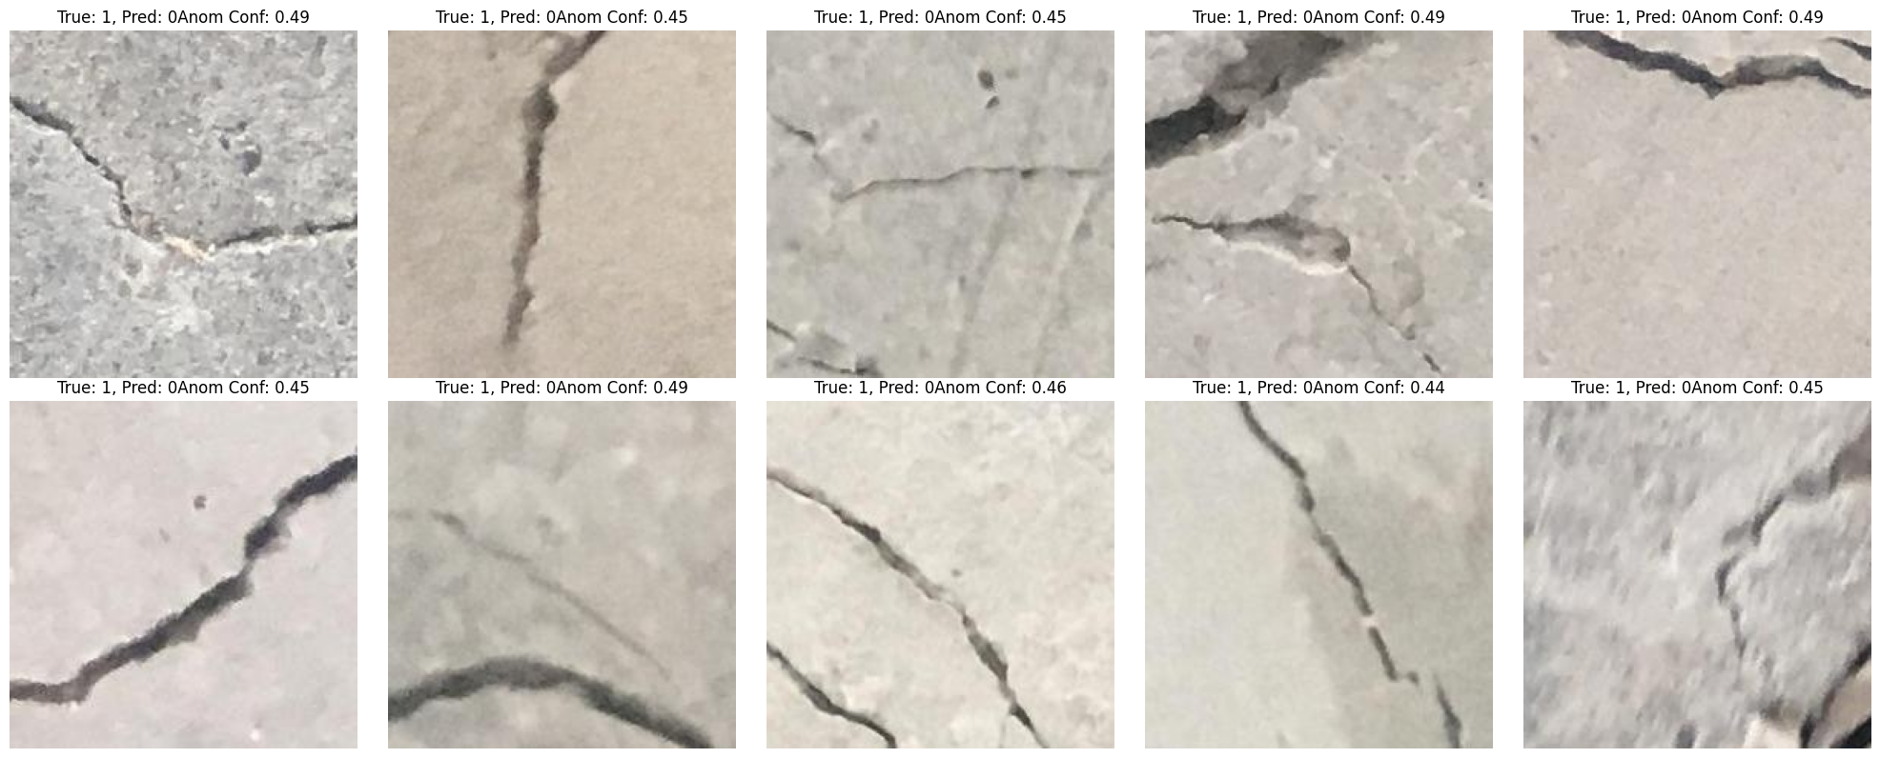

False positive:
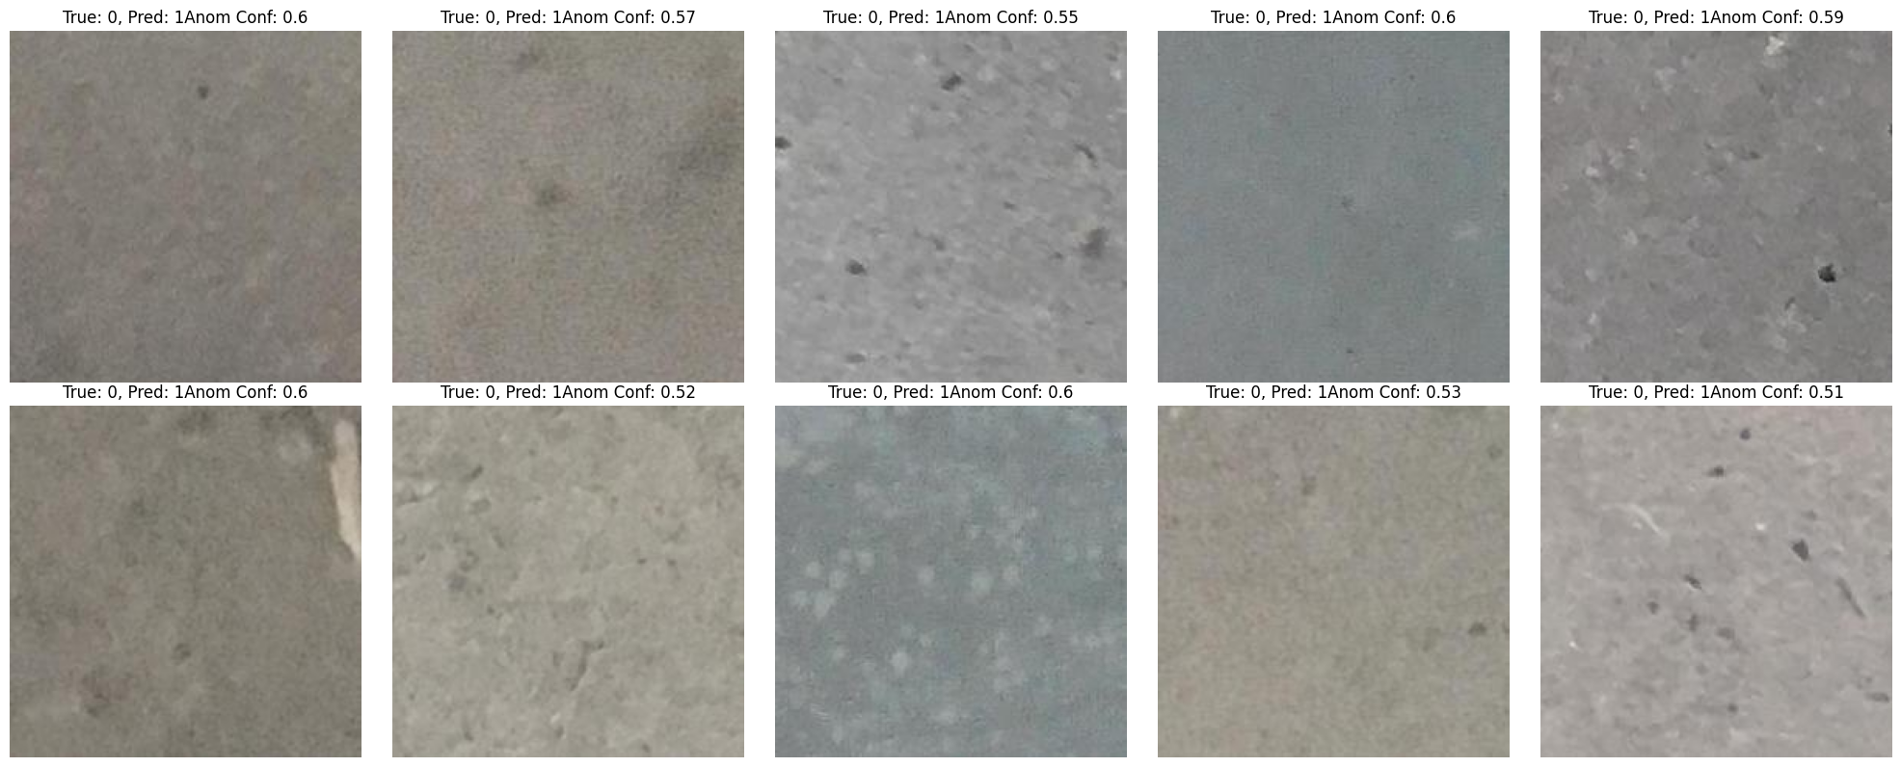

Unbalanced

Metric | Value
Accuracy | 0.834
F1 Score Weighted | 0.887
F1 Score | 0.2589
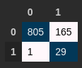

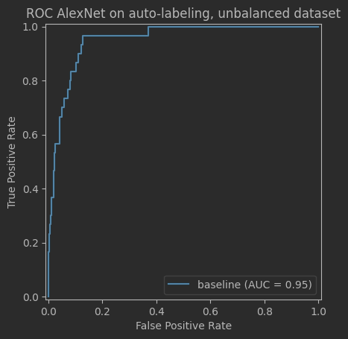

There is a lot of space of improvements. (At lest annotation algo can be tuned to ~0.99% accuracy, so the DL approach too). Due to lack of time for experiments I had no possibility to tune DL approach and peer review dataset to make another data -> preprocessing -> train spin.
What I would also do:
- Add more data augmentation
- Tune auto-labeling algo
- Move DL model to gray scale
- Experiment with other models

Conclusion
Training and test of the DL model can be found in the train.ipynb. Data exploration and test of the heuristic algo in the research.ipynb, folder models contains heuristic algo,folder dataset contains datasets.
The results from the auto-annotation algo exceeded my expectations and suggests that there is possibility to solve the problem solely by using heuristic algo based on CV processing and algorithms. Also, f1 0.89 for the AlexNet is far from annotation error, so there is a lot room for improvement for the data preprocesing for the model.
That was interesting :)

